Stage 1 – First Port Of Call
COURSE DESIGNER: Ike Starnes
SCORING: Comstock 28 rounds.
TARGETS: 14 cardboard targets
SCORED HITS: 2 Best hits per carboard will be scored.
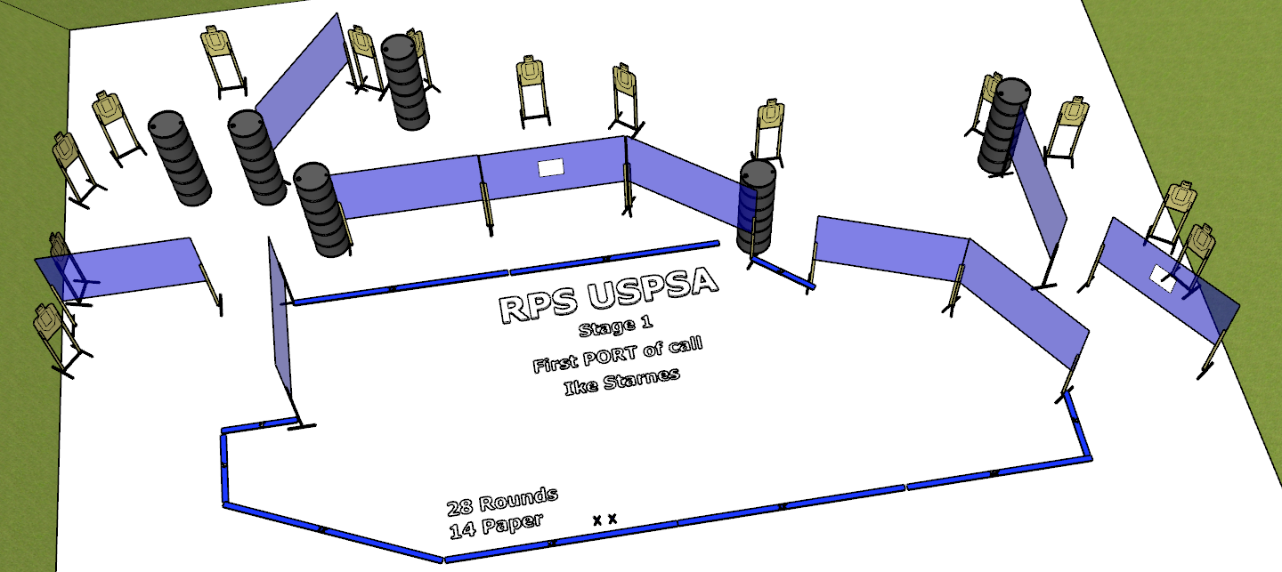

Written Stage Briefing:

Stage 1 – First Port Of Call - is a 28 round, 140 point, Comstock Course. There are 14 cardboard targets.

Starting with both feet on the Shooting Sports Innovations Xs.
Handgun is loaded and holstered, wrists below belt.
PCC is loaded held in both hands, stock on belt.

On the audible start signal, engage targets from within the shooting area.

USPSA / NROI Range Commands:
- Make Ready
- Are you ready?
- Standby
- If finished, unload and show clear
- If clear, hammer down and holster (Handgun)
If clear, hammer down and flag (PCC)
If clear, cylinder closed and holster (Revolver)
- Range is clear

Setup Notes:
14 Single Wall Stands
3 Double Wall Stands
5 Full Walls
2 Port Wall2
1 Half Wall
15 Target stands / 30 target sticks
14+ barrels


